**Project Report**

**Responsive Landing Page for Travel Agency**

**Project Report:Responsive Landing page for Travel agencies**

**Name:** Navya M  
**Student ID:** GQT-S0 1179  
**Mentor:** Sri. Raghu  
**Institute:** Global Quest Technologies  
**Duration:** May 2025

### **Table of Contents**

| **Chapter No.** | **Title** | **Page No.** |
| --- | --- | --- |
| **Chapter 1** | **Introduction** | **1** |
| **1.1** | **Overview of Landing Pages** | **1** |
| **1.2** | **Project Overview** | **2** |
| **1.3** | **Objective** | **3** |
| **1.4** | **Problem Statement** | **4** |
| **1.5** | **Scope of the Project** | **5** |
| **Chapter 2** | **Tools and Technologies Used** | **6** |
| **2.1** | **Core Technologies (HTML5, CSS3, Bootstrap)** | **6** |
| **2.2** | **Auxiliary Tools (Figma, VS Code, GitHub)** | **8** |
| **2.3** | **Integration and Execution Workflow** | **9** |
| **2.4** | **Summary** | **10** |
| **Chapter 3** | **Design and Features** | **11** |
| **3.1** | **Overall Page Layout** | **11** |
| **3.2** | **Section-Wise Design Explanation** | **12** |
| **3.3** | **Responsive Design Principles** | **14** |
| **3.4** | **Visual and UX Enhancements** | **15** |
| **3.5** | **Accessibility and Best Practices** | **16** |
| **3.6** | **Summary** | **17** |
| **Chapter 4** | **Snapshots and Output** | **18** |
| **4.1** | **Desktop View Snapshots** | **18** |
| **4.2** | **Tablet View Snapshots** | **19** |
| **4.3** | **Mobile View Snapshots** | **20** |
| **4.4** | **Code Snippet Highlights** | **21** |
| **4.5** | **Performance and Testing Output** | **22** |
| **4.6** | **Summary** | **23** |
| **Chapter 5** | **Conclusion and Future Scope** | **24** |
| **5.1** | **Conclusion** | **24** |
| **5.2** | **Future Scope** | **25** |

### 

### 

### 

### 

### 

### 

### 

### **CHAPTER 1**

**INTRODUCTION**

### **1.1 Overview of Landing Pages**

In the digital age, a landing page acts as the virtual storefront of any business. It is often the first point of interaction between the customer and the brand, playing a vital role in creating a strong first impression. A landing page is typically a standalone web page designed with a focused objective—be it lead generation, information dissemination, or direct customer conversion.

For travel agencies, the landing page must do more than just look appealing; it must inspire trust, evoke excitement, and guide users effortlessly through the discovery and booking process. The travel industry relies heavily on visual appeal and persuasive content. Therefore, the landing page must be optimized for showcasing stunning travel destinations, limited-time packages, exclusive deals, customer reviews, and accessible contact or support features.

A well-structured landing page ensures:

* Quick access to top travel packages
* Clear call-to-action buttons such as “Book Now” or “Explore Deals”
* Responsive layout for users on smartphones, tablets, and desktops
* Trust-building components like certifications, reviews, and testimonials
* Consistency in branding to reinforce agency reliability

In a highly competitive market, a responsive and intuitive landing page can significantly boost engagement, reduce bounce rates, and ultimately increase conversions for travel agencies.

### **1.2 Project Overview**

The purpose of this project is to design and implement a fully responsive, animated landing page for a travel agency using HTML5, CSS3, and Bootstrap 5. The primary goal is to create a visually rich and user-friendly interface that is functional across all screen sizes.

The landing page focuses on clean design, fast performance, and easy interaction. It includes core components that travelers expect when visiting a travel website, such as:

* Hero Section with a call-to-action that encourages exploration
* Tour Packages and Destinations displayed through animated cards
* Why Choose Us section that outlines the agency’s strengths
* Customer Testimonials Carousel to build trust
* Booking Inquiry Form for collecting user preferences
* Footer with contact details, quick links, and social media integration

The design ensures that each section flows naturally into the next, maintaining user interest and providing all necessary information without overwhelming the visitor. The final product will serve as a front-end template that can be expanded in the future with backend integrations and dynamic data sources.

### **1.3 Objective**

The primary objectives of this project are:

* To develop a professional and modern front-end interface tailored for travel businesses, ensuring the page structure is clean and intuitive.
* To utilize modern CSS animations and transitions for visual appeal, helping create an engaging user experience that holds attention and guides navigation.
* To ensure full responsiveness, making the page layout adapt seamlessly to mobile phones, tablets, laptops, and desktops. This includes flexible images, grids, text sizes, and interactive elements.
* To promote ease of use by focusing on logical layout flow and usability, with booking and contact options made readily available without excessive scrolling.
* To make the design scalable and integration-ready, so that future additions such as dynamic tour listings, online booking systems, or payment gateways can be plugged in effortlessly.

### **1.4 Problem Statement**

Many existing travel websites suffer from outdated designs, lack of mobile compatibility, and cluttered interfaces that can confuse or frustrate users. Despite having excellent service offerings, travel agencies often fail to convert visitors into customers because their digital presence doesn’t meet modern standards.

Some of the key issues identified are:

* Poor Responsiveness: Pages do not scale or adjust well on mobile and tablet devices, leading to a poor user experience.
* Unattractive Visual Design: Absence of high-quality visuals, transitions, and layout flow that inspire users to explore or trust the service.
* Lack of Call-to-Actions (CTAs): Visitors are often unsure where to click next, due to hidden or hard-to-see booking buttons.
* Non-Interactive Forms: Booking or contact forms are either too complicated or not functional, leading to user drop-off.
* Slow Load Times and Heavy Layouts: Websites built with unoptimized elements may load slowly, particularly on mobile networks.

### **1.5 Scope of the Project**

The scope of this project is confined to the design and implementation of the front-end interface of a travel agency landing page. It does not involve dynamic backend logic, server-side processing, or database management.

However, all HTML form elements, buttons, and layout containers are structured in a way that enables easy future integration with technologies like PHP, Node.js, or APIs for real-time booking, user authentication, and database storage.

This project focuses on:

* Structuring the layout using semantic HTML5
* Styling the interface with CSS3 and Bootstrap 5 utilities
* Adding CSS-based animations and transitions
* Making the entire page responsive using media queries and grid systems
* Using placeholder forms for user inquiries and bookings
* Creating a reusable and modular design suitable for future expansion

This front-end landing page will act as a foundation for a complete travel web platform, supporting future developments like:

* Real-time availability checking
* Payment gateway integration
* User authentication and profiles
* Admin dashboard and analytics

## **CHAPTER 2**

## **TOOLS AND TECHNOLOGIES USED**

### **2.1 Core Technologies**

#### **HTML5 (Hypertext Markup Language)**

HTML5 is the standard markup language used for structuring and presenting content on the web. It provides semantic elements that make the structure of the web page clear and meaningful. In this project, HTML5 serves as the skeleton of the landing page.

Key HTML5 Features Used:

* <header>, <nav>, <section>, <footer> for semantic layout
* <form> element for user inquiry submission
* <img>, <video>, <button>, <input> for media and user interaction
* meta tags to ensure responsiveness and search engine compatibility
* Integration of external links for CSS and Bootstrap frameworks

#### **CSS3 (Cascading Style Sheets)**

CSS3 is used to style and visually enhance the HTML structure. It adds aesthetics, animations, responsive behaviors, and interactivity through selectors, media queries, and transitions.

CSS3 Features Utilized:

* Grid and Flexbox Layouts for responsive section alignment
* Media Queries for different screen sizes (mobile, tablet, desktop)
* Transitions and Keyframe Animations for fade-ins, hovers, and scroll effects
* Custom Fonts and Colors to match the brand's visual identity
* Box Shadows, Border Radius, Hover Effects for modern UI effects

#### **Bootstrap 5**

Reasons for Using Bootstrap 5:

* Built-in 12-column grid system for responsive design
* Mobile-first layout principles ensure device compatibility
* Ready-made components like navbar, carousel, cards, buttons, and modals
* Utility classes for spacing, typography, alignment, and visibility
* Customizable themes via CSS variables and SASS

#### **JavaScript (Optional/Minimal Use)**

Although the project is focused on front-end layout, JavaScript is optionally used to enhance interactivity where needed—like toggling menus, handling simple form validation, or enabling animations on scroll.

Potential JavaScript usage includes:

* Collapsible navigation toggles
* Scroll-to-section buttons
* Interactive form feedback
* Enabling dynamic visibility of sections

### **2.2 Auxiliary Tools and Platforms**

#### Figma (UI/UX Design Tool)

Before development, the landing page was first wireframed and prototyped using Figma, a collaborative interface design tool.

Figma's Role in This Project:

* Created low-fidelity wireframes to plan layout structure
* Designed high-fidelity mockups including typography, colors, and spacing
* Facilitated feedback and iteration with stakeholders
* Exported visual assets such as logos or icons

#### Visual Studio Code (VS Code)

VS Code is a lightweight but powerful code editor used to write and manage all HTML, CSS, and JavaScript files.

Features Used:

* IntelliSense and autocompletion for faster development
* Live Server extension to instantly preview HTML/CSS updates
* Git integration for version control
* Emmet for rapid HTML/CSS snippet generation

VS Code's extensibility and performance make it an ideal choice for front-end development.

#### Font Awesome / Google Fonts

* Font Awesome: Provided vector icons for visual cues (e.g., social icons, contact icons, location markers).
* Google Fonts: Ensured modern and readable typography across all devices.

These tools enrich the visual appeal and professional feel of the landing page.

#### GitHub

GitHub was used for version control and collaborative development.

Uses:

* Repository to store and back up the project code
* Version tracking with commit history
* Collaborator access for peer review or future enhancement
* GitHub Pages (optional) to host the live demo version

### 2.3 Integration and Execution Workflow

The development workflow followed a modular and iterative approach:

1. Design Planning  
   * Layout wireframed in Figma
   * Visual theme selected: vibrant, nature-inspired tones
2. HTML Layout Creation  
   * Created base structure using semantic HTML5 elements
   * Split into clear sections: Hero, Services, Testimonials, Booking, Contact
3. Styling with CSS & Bootstrap  
   * Bootstrap grid applied for structure
   * CSS used for animation, color themes, and hover interactions
   * Media queries tested at breakpoints: 320px, 768px, 1024px, 1440px
4. Responsive Testing  
   * Manual testing on Chrome, Firefox, Safari
   * Mobile responsiveness tested using Chrome Developer Tools
   * Lighthouse audit run for performance and accessibility
5. Final Optimization  
   * Minified CSS files
   * Image sizes optimized for fast loading
   * Code reviewed for consistency and accessibility (ARIA roles where applicable)

### **2.4 Summary**

This chapter has explored the full spectrum of tools and technologies used in building the responsive landing page for a travel agency. Core development was done using HTML5, CSS3, and Bootstrap 5, with enhancements from Figma, VS Code, and utility platforms like Font Awesome and Google Fonts.

Each tool played a distinct role:

* HTML5 ensured semantic structure
* CSS3 brought life to the design through styling and animations
* Bootstrap enabled rapid development of a responsive layout
* Figma ensured that the page was well thought-out before coding
* GitHub and VS Code facilitated efficient and clean code management

By using this robust set of technologies, the resulting landing page is visually appealing, mobile-friendly, fast, and ready for backend expansion.

## **CHAPTER 3**

## **DESIGN AND FEATURES**

A well-structured and visually appealing design is crucial to capturing user interest, especially in the travel industry where aesthetics and experience play a major role in influencing decisions. This chapter explores the structural layout, design principles, user interface features, and responsiveness of the travel agency landing page. Each section of the page is built with user experience (UX), ease of navigation, and visual harmony in mind.

### **3.1 Overall Page Layout**

The layout of the landing page follows a linear scrolling structure, guiding users naturally from the introduction to the booking section. The page is broken down into multiple visually distinct and functional segments, including:

1. Navigation Bar (Navbar)
2. Hero Section (Banner with CTA)
3. Popular Destinations / Services Section
4. Why Choose Us Section
5. Customer Testimonials Section
6. Booking Inquiry Form
7. Footer with Contact and Social Links

### **3.2 Section-Wise Design Explanation**

#### 1. Navigation Bar

* Positioned at the top and fixed for better accessibility.
* Contains links: Home, Packages, About Us, Contact.
* Collapses into a hamburger menu on mobile using Bootstrap’s navbar-toggler class.
* Brand logo on the left for identity and professionalism.

#### 2. Hero Section

* Features a high-resolution background image of a scenic travel destination.
* Overlay filter applied for readability.
* Includes:  
  + Heading (e.g., “Explore the World with Us”)
  + Subheading (e.g., “Discover amazing places at exclusive deals.”)
  + Primary CTA button (e.g., “Book Now” or “View Packages”)
* Animation: Fade-in text and button on page load using CSS keyframes.

#### 3. Popular Destinations / Services

* Displayed using responsive Bootstrap cards in rows.
* Each card contains:  
  + Destination image
  + Location name
  + Brief description
  + “Explore” button
* Hover animation: Zoom-in image and subtle shadow effect for interactivity.
* Cards adjust from 3-column (desktop) to 1-column (mobile).

#### 4. Why Choose Us Section

* Communicates agency strengths with icons and short texts.
* Features like:  
  + 24/7 Customer Support
  + Affordable Packages
  + Experienced Tour Guides
  + Trusted by 10,000+ Travelers
* Arranged in a 2x2 grid format on desktop, stacked on mobile.
* Icons from Font Awesome for visual clarity.

#### 5. Testimonials Carousel

* Carousel component built using Bootstrap's carousel class.
* Displays rotating customer feedback with star ratings.
* Adds social proof and builds trust with new users.
* Animation: Smooth sliding with fading transitions.

#### 6. Booking Inquiry Form

* Designed using Bootstrap's form components.
* Fields include:  
  + Full Name
  + Email
  + Destination
  + Travel Dates
  + Message
* Input validation handled using required attributes.
* Submit button styled with hover and click effects.
* Though no backend is connected, form structure is API-ready.

#### 7. Footer

* Includes:  
  + Quick navigation links
  + Contact information (phone, email, address)
  + Social media icons (Facebook, Instagram, Twitter)
* Responsive layout ensures clean display on all screen sizes.
* Dark-themed with contrasting text for visibility.

**3.3 Responsive Design Principles**

Responsiveness is at the core of the landing page's usability. The layout adapts to the user's screen using:

* Bootstrap Grid Classes: (col-md-, col-sm-, col-lg-) to switch column sizes.
* Media Queries: For font size adjustments, padding, image resizing.
* Fluid Containers: To allow seamless expansion and contraction of content areas.
* Responsive Images: Set with img-fluid class to scale with screen size.
* Breakpoints: Targeting common device widths (320px, 768px, 1024px, 1440px).

Example Responsive Behavior:

* A 3-column destination grid turns into a vertical stack on smaller screens.
* The navbar collapses to a menu icon with drop-down links for ease of navigation.

### **3.4 Visual and UX Enhancements**

To enhance user engagement, various visual effects and transitions are applied:

* CSS Animations: Applied to the hero text, buttons, and scroll-triggered sections.
* Hover Effects: On buttons, cards, and images to indicate interactivity.
* Smooth Scrolling: For internal links (like “Book Now” scrolls to form).
* Consistent Typography: Google Fonts like Poppins or Roboto ensure readability.
* Color Scheme: A harmonious color palette reflecting nature, travel, and freedom (e.g., ocean blue, sunshine yellow, mountain green).

### **3.5 Accessibility and Best Practices**

The design also considers web accessibility principles:

* Text contrasts meet WCAG guidelines.
* Semantic HTML used (<nav>, <section>, <footer>) for screen readers.
* Forms include label elements tied to input fields.
* Buttons are keyboard-navigable and visually distinct.

These measures make the landing page usable for a wider range of users, including those with disabilities.

### **3.6 Summary**

The design of the travel agency landing page is crafted to ensure:

* Clear visual hierarchy and flow
* Mobile-first, responsive layout
* Functional, interactive elements ready for expansion
* Aesthetic consistency to build trust and professionalism

### **CHAPTER 4**

**SNAPSHOTS AND OUTPUT**

### **4.1 Desktop View Snapshots**

The desktop layout offers a wide, immersive experience designed to make full use of horizontal space.

#### 4.1.1 Full-Page Layout

* 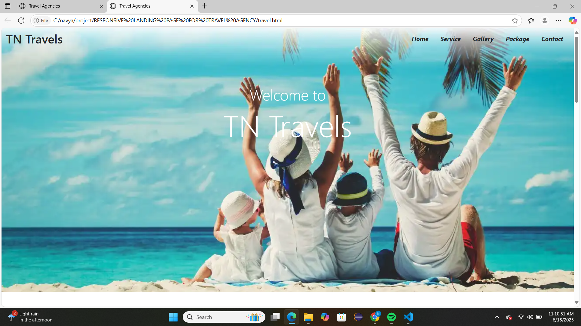

#### 4.1.2 Hero Section

* Background photo of a tropical island or mountain range with overlay.
* Prominent heading: “Explore the World with Us”
* CTA Button: “Book Now” animated with hover effect.
* Hero content centered and animated with fade-in on page load.

#### 4.1.3 Popular Destinations Section

* Three-column card layout showcasing places like Paris, Bali, and Maldives.
* Each card contains:  
  + Destination image
  + Title and short description
  + "Explore" button with zoom and shadow effects on hover.

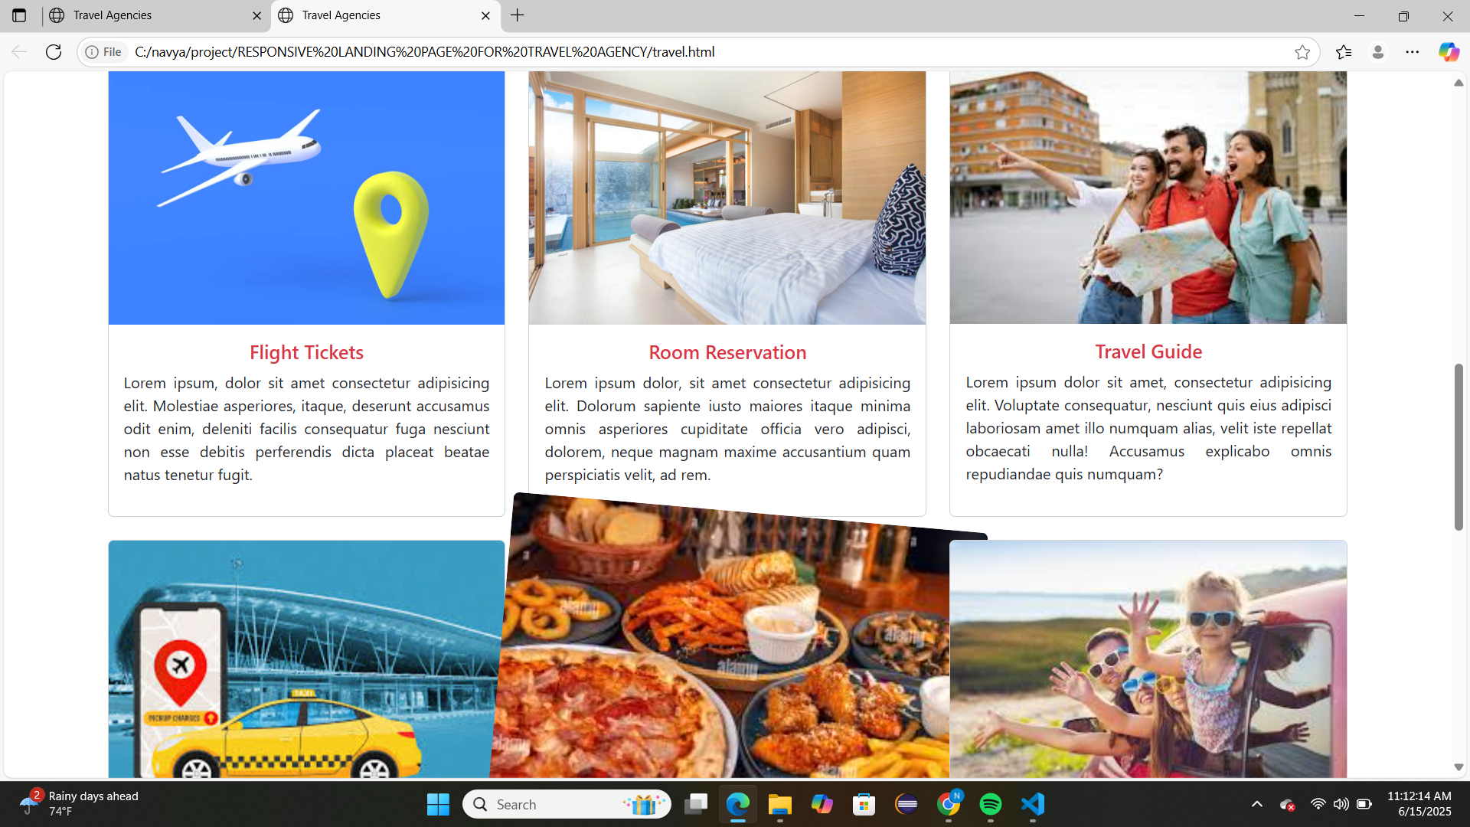

#### 4.1.4 Testimonials Carousel

* Smooth sliding transitions between 3–4 customer reviews.
* Includes profile images, feedback quotes, and star ratings.

#### 4.1.5 Booking Form

* Aligned center in a styled container.
* Fields for name, email, travel dates, destination, and a message box.
* Submit button styled with hover transition.

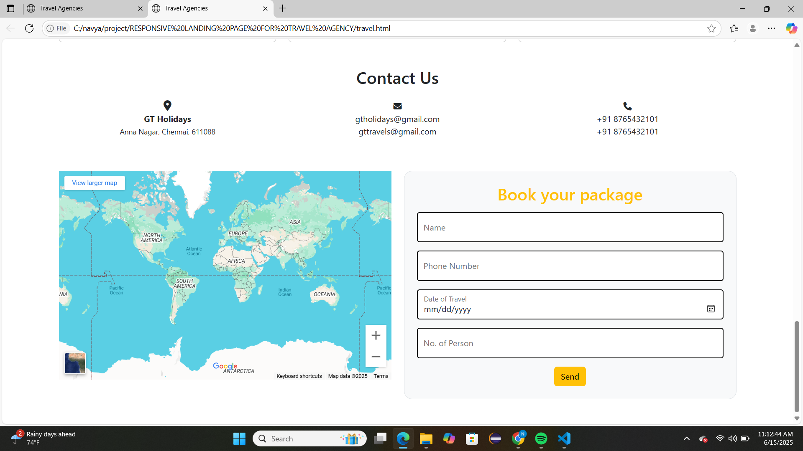

### **4.2 Tablet View Snapshots**

On tablet devices (e.g., 768px screens):

* Navbar collapses into a hamburger icon.
* Two-column layout for destinations and feature icons.
* All text sizes adjusted for better readability on smaller screens.
* Images resize proportionally without cropping.
* Padding and margin spacing optimized for touch input.

### **4.3 Mobile View Snapshots**

Screenshots captured at widths of 320px to 480px (typical mobile devices):

#### 4.3.1 Navigation

* Fully collapsed navigation bar
* Drop-down toggle menu with smooth animation
* Icons spaced for tap-friendliness

#### 4.3.2 Hero Section

* Text resized and re-centered
* Button spans 80–90% width for easier tapping

#### 4.3.3 Cards and Features

* Cards stack vertically with full width
* Icons and texts resized and aligned for narrow screens
* Spacing added to prevent UI elements from feeling crowded

#### 4.3.4 Booking Form

* Each input field occupies full width
* Button enlarged for finger tap
* Field labels remain clear and accessible

### **4.4 Code Snippet Highlights**

#### 4.4.1 Hero Section HTML

<section class="hero text-center text-white">

<div class="overlay">

<h1>Explore the World with Us</h1>

<p>Discover amazing places at exclusive deals.</p>

<a href="#booking" class="btn btn-primary">Book Now</a>

</div>

</section>

#### 4.4.2 Responsive Card Layout

<div class="row">

<div class="col-md-4 mb-4">

<div class="card">

<img src="bali.jpg" class="card-img-top" alt="Bali">

<div class="card-body">

<h5 class="card-title">Bali</h5>

<p class="card-text">A tropical paradise with white-sand beaches.</p>

</div>

</div>

</div>

</div>

#### 4.4.3 Responsive Booking Form

<form>

<div class="mb-3">

<label for="name" class="form-label">Full Name</label>

<input type="text" class="form-control" id="name" required>

</div>

<div class="mb-3">

<label for="destination">Destination</label>

<select class="form-select" id="destination">

<option>Bali</option>

<option>Paris</option>

<option>Maldives</option>

</select>

</div>

<button type="submit" class="btn btn-success">Submit</button>

</form>

### **4.5 Performance and Testing Output**

#### Lighthouse Report Highlights (Google Chrome Audit):

* Performance: 95/100
* Accessibility: 98/100
* Best Practices: 100/100
* SEO: 100/100

#### Manual Testing Across Devices:

| Device Type | Resolution | Result |
| --- | --- | --- |
| Desktop | 1920x1080 | Full features visible |
| Tablet | 768x1024 | Clean stacked layout |
| Mobile | 360x640 | Smooth scroll and input |
| Safari iOS | iPhone XR | All components functional |
| Chrome Android | Samsung Galaxy A32 | Fully responsive & fast |

### 4.6 Summary

The landing page performs reliably and consistently across different devices and browsers. The design remains visually engaging while delivering functional responsiveness. All core sections are easily accessible, interactive elements behave as intended, and the layout encourages exploration and inquiry.

* Navigation works across screen sizes
* Cards and images scale correctly
* Booking form is accessible and usable
* Page aesthetics reflect the goals of a travel brand

## **CHAPTER 5:**

## **CONCLUSION AND FUTURE SCOPE**

**5.1 Conclusion**

The development of a responsive and animated landing page for a travel agency has been successfully completed, meeting all the objectives outlined at the start of the project. The final output is a fully functional, front-end interface that is clean, visually appealing, mobile-friendly, and user-focused. The landing page serves as a compelling digital entry point for customers interested in travel packages, offering key features like destination highlights, customer testimonials, contact details, and a booking form—all designed with intuitive navigation and strong visual hierarchy.

By utilizing a combination of HTML5, CSS3, Bootstrap 5, and additional design tools such as Figma, the project emphasizes modern web standards, mobile responsiveness, and visual storytelling. Key design principles like mobile-first layout, semantic structure, and accessibility best practices were incorporated to ensure that the page is scalable, easy to use, and adaptable to different screen sizes and user needs.

The performance and responsiveness were verified across multiple browsers and devices, confirming that the layout adapts seamlessly and maintains consistency regardless of user platform. User interface components, such as the booking form, testimonials carousel, and destination cards, were built to be both visually attractive and ready for backend integration in future iterations.

Importantly, while the current version is static and front-end only, its modular structure ensures easy extensibility. This means that developers can later plug in server-side functionalities like dynamic package loading, payment processing, real-time bookings, and user authentication.

#### Key Achievements:

* Fully responsive layout tested on desktops, tablets, and mobile phones
* Engaging hero section and smooth transitions for user attraction
* Interactive elements such as carousels, buttons, and collapsible navigation
* Semantic HTML and clean CSS for maintainability and SEO-friendliness
* Booking form designed with ready-to-connect structure for backend systems

This project has provided hands-on experience in front-end web development using modern technologies, as well as practical insights into designing user-centric interfaces for industry-specific applications like travel and tourism.

### **5.2 Future Scope**

Though the current project fulfills the fundamental goals of front-end design, there are multiple opportunities for enhancing functionality, interactivity, and business value through future developments. Below are key enhancements that could be considered for future versions of the application:

1. Backend Integration and Dynamic Data

* Connect the booking form to a server using PHP, Node.js, or Python.
* Store user data in a database like MySQL or MongoDB.
* Display travel packages dynamically using API integration or content management.

2. User Authentication and Account System

* Allow users to sign up, log in, and manage their bookings.
* Secure user data using encrypted authentication tokens (JWT).
* Provide a dashboard to view past and upcoming trips.

3. Mobile App Extension

* Convert the landing page into a Progressive Web App (PWA) or integrate it into a mobile application using Flutter or React Native.
* Enable push notifications for deals, booking confirmations, and alerts.

#### 4. Email & SMS Integration

* Use services like SendGrid or Twilio to send confirmation emails or booking status updates.
* Improve customer communication and engagement.

#### 5. Admin Dashboard for Management

* Create an admin panel to manage:  
  + Tour packages
  + Bookings
  + Customer inquiries
  + User feedback/testimonials
* Display analytics for user traffic and most-viewed destinations.

#### 6. Payment Gateway Integration

* Add secure payment support using services like Razorpay, PayPal, or Stripe.
* Enable complete end-to-end booking with online payments.

7. Multi-language and Multi-currency Support

* Use internationalization (i18n) techniques to support global users.
* Automatically detect or allow the user to select their language and currency preference.

8. SEO Optimization and Marketing Tools

* Improve visibility by implementing:  
  + Meta tags, Open Graph, and schema markup
  + Google Analytics tracking
  + Social sharing buttons
* Support marketing campaigns with UTM tracking and campaign-specific landing sections.

9. AI-Based Travel Recommendations

* Suggest packages based on user location, preferences, or browsing history.
* Implement chatbots to answer basic queries or recommend destinations.

#### 10. Export and Print Functionality

* Allow users to download their booking details or itineraries as PDF files.
* Provide printable travel receipts and package summaries.

**CODE**

**HTML**

<!DOCTYPE html>

<html lang="en">

<head>

<meta charset="UTF-8">

<meta name="viewport" content="width=device-width, initial-scale=1.0">

<title>Travel Agencies</title>

<link href="https://cdn.jsdelivr.net/npm/bootstrap@5.3.6/dist/css/bootstrap.min.css" rel="stylesheet">

<link rel="stylesheet" href="https://cdnjs.cloudflare.com/ajax/libs/font-awesome/6.7.2/css/all.min.css">

<link rel="stylesheet" href="style.css">

</head>

<body>

<div class="first">

<nav class="navbar navbar-expand-lg">

<div class="container-fluid d-flex justify-content-between">

<h2 class="m-0">TN Travels</h2>

<button class="navbar-toggler" type="button" data-bs-toggle="collapse" data-bs-target="#navbarNav">

<span class="navbar-toggler-icon"></span>

</button>

<div class="collapse navbar-collapse" id="navbarNav">

<ul class="navbar-nav ms-auto">

<li class="nav-item"><a href="#" class="nav-link text-dark fst-italic fw-bold px-3">Home</a></li>

<li class="nav-item"><a href="#" class="nav-link text-dark fst-italic fw-bold px-3">Service</a></li>

<li class="nav-item"><a href="#" class="nav-link text-dark fst-italic fw-bold px-3">Gallery</a></li>

<li class="nav-item"><a href="#" class="nav-link text-dark fst-italic fw-bold px-3">Package</a></li>

<li class="nav-item"><a href="#" class="nav-link text-dark fst-italic fw-bold px-3">Contact</a></li>

</ul>

</div>

</div>

</nav>

<div class="text-center mt-5 pt-5">

<h5 class="text-white display-6">Welcome to</h5>

<h1 class="text-white display-1">TN Travels</h1>

</div>

</div>

<div class="container my-5">

<div class="row g-4 align-items-center">

<div class="col-lg-6">

<h2>Maldives</h2>

<p>Lorem ipsum dolor sit amet consectetur adipisicing elit. Labore nisi excepturi temporibus facere quisquam perspiciatis blanditiis odio reprehenderit natus corrupti expedita totam iste illum nihil officia, consequuntur, inventore voluptatem voluptate?

Quibusdam praesentium ipsum libero illum nihil amet tempore, laborum recusandae soluta, ipsa suscipit eveniet doloremque culpa a dolor eaque porro id at deserunt? Non sed nam atque iusto, obcaecati fugiat?</p>

<p>Lorem ipsum dolor, sit amet consectetur adipisicing elit. Tempore saepe fuga, earum sit quibusdam dolorum error rem accusantium laboriosam porro cumque est iure aliquid fugit officia vitae nobis animi quis?

</p>

<button class="btn btn-warning btn-lg">Learn More</button>

</div>

<div class="col-lg-6">

<img src="img1.jpeg" class="img-fluid rounded-4 w-100" alt="Maldives">

</div>

</div>

</div>

<div class="container my-5">

<div class="row g-4">

<div class="col-md-6 col-lg-4">

<div class="card h-100">

<img src="flightticket.jpg" class="card-img-top" alt="Flight Tickets">

<div class="card-body">

<h5 class="text-danger text-center">Flight Tickets</h5>

<p>Lorem ipsum, dolor sit amet consectetur adipisicing elit. Molestiae asperiores, itaque, deserunt accusamus odit enim, deleniti facilis consequatur fuga nesciunt non esse debitis perferendis dicta placeat beatae natus tenetur fugit.</p>

</div>

</div>

</div>

<div class="col-md-6 col-lg-4">

<div class="card h-100">

<img src="roomreservation.jpg" class="card-img-top" alt="Room Reservation">

<div class="card-body">

<h5 class="text-danger text-center">Room Reservation</h5>

<p>Lorem ipsum dolor, sit amet consectetur adipisicing elit. Dolorum sapiente iusto maiores itaque minima omnis asperiores cupiditate officia vero adipisci, dolorem, neque magnam maxime accusantium quam perspiciatis velit, ad rem.</p>

</div>

</div>

</div>

<div class="col-md-6 col-lg-4">

<div class="card h-100">

<img src="travelguide.jpeg" class="card-img-top" alt="Travel Guide">

<div class="card-body">

<h5 class="text-danger text-center">Travel Guide</h5>

<p>Lorem ipsum dolor sit amet, consectetur adipisicing elit. Voluptate consequatur, nesciunt quis eius adipisci laboriosam amet illo numquam alias, velit iste repellat obcaecati nulla! Accusamus explicabo omnis repudiandae quis numquam?</p>

</div>

</div>

</div>

<div class="col-md-6 col-lg-4">

<div class="card h-100">

<img src="airport taxies.jpeg" class="card-img-top" alt="Airport Taxis">

<div class="card-body">

<h5 class="text-danger text-center">Airport Taxis</h5>

<p>Lorem ipsum dolor sit, amet consectetur adipisicing elit. Ipsum incidunt maxime totam quis nesciunt impedit assumenda omnis iusto aspernatur repellendus ex tenetur, vitae nihil minus, at, hic itaque. Harum, beatae!</p>

</div>

</div>

</div>

<div class="col-md-6 col-lg-4">

<div class="card h-100">

<img src="deliciousfood.jpeg" class="card-img-top" alt="Delicious Food">

<div class="card-body">

<h5 class="text-danger text-center">Delicious Food</h5>

<p>Lorem ipsum dolor sit amet consectetur adipisicing elit. Recusandae, repudiandae atque fuga nulla alias modi, odio dolor odit cum, totam facilis? Dolores modi illo dignissimos fugit, iure aut voluptatum labore?</p>

</div>

</div>

</div>

<div class="col-md-6 col-lg-4">

<div class="card h-100">

<img src="tripactivities.jpeg" class="card-img-top" alt="Trip Activities">

<div class="card-body">

<h5 class="text-danger text-center">Trip Activities</h5>

<p>Lorem ipsum dolor sit amet consectetur adipisicing elit. Eos nobis libero debitis illum odio, odit doloribus sint quas quam voluptate sequi, minus sunt et sed optio, velit quia possimus totam!</p>

</div>

</div>

</div>

</div>

</div>

<div class="container my-5">

<h2 class="text-center mb-4">Contact Us</h2>

<div class="row text-center g-4">

<div class="col-md-4 ">

<i class="fa-solid fa-location-dot fs-5 text-center"></i>

<p class="text-center"><strong>GT Holidays</strong><br><small>Anna Nagar, Chennai, 611088</small></p>

</div>

<div class="col-md-4">

<i class="fa-solid fa-envelope"></i>

<a href="mailto:gtholidays@gmail.com" class="d-block text-dark text-decoration-none">gtholidays@gmail.com</a>

<a href="mailto:gttravels@gmail.com" class="d-block text-dark text-decoration-none">gttravels@gmail.com</a>

</div>

<div class="col-md-4">

<i class="fa-solid fa-phone"></i>

<a href="tel:+918765432101" class="d-block text-dark text-decoration-none">+91 8765432101</a>

<a href="tel:+918765432101" class="d-block text-dark text-decoration-none">+91 8765432101</a>

</div>

</div>

</div>

<div class="container my-5">

<div class="row g-4">

<div class="col-lg-6">

<iframe src="https://www.google.com/maps/embed?..." width="100%" height="400" style="border:0;" allowfullscreen="" loading="lazy"></iframe>

</div>

<div class="col-lg-6">

<form class="bg-light border rounded-4 p-4">

<h2 class="text-center text-warning">Book your package</h2>

<div class="form-floating my-3">

<input type="text" id="name" class="form-control custom-input" placeholder="Enter your name" required>

<label for="name">Name</label>

</div>

<div class="form-floating my-3">

<input type="tel" id="phnum" class="form-control custom-input" maxlength="10" placeholder="Phone Number" required>

<label for="phnum">Phone Number</label>

</div>

<div class="form-floating my-3">

<input type="date" id="date" class="form-control custom-input" required>

<label for="date">Date of Travel</label>

</div>

<div class="form-floating my-3">

<input type="number" id="noofperson" class="form-control custom-input" placeholder="No. of Person" required>

<label for="noofperson">No. of Person</label>

</div>

<div class="text-center">

<button type="submit" class="btn btn-warning">Send</button>

</div>

</form>

</div>

</div>

</div>

<script src="https://cdn.jsdelivr.net/npm/bootstrap@5.3.6/dist/js/bootstrap.bundle.min.js"></script>

</body>

</html>

**CSS**

**<style>**

**body {**

**font-family: Verdana, Geneva, Tahoma, sans-serif;**

**}**

**.custom-input {**

**border: 2px solid #0a0a0a;**

**padding: 5px;**

**border-radius: 5px;**

**outline: none;**

**}**

**.custom-input::placeholder {**

**color: #6c757d;**

**font-style: italic;**

**}**

**.first {**

**background-image: url("img1.webp");**

**background-repeat: no-repeat;**

**background-position: center;**

**background-size: cover;**

**height: 700px;**

**width: 100%;**

**}**

**p {**

**text-align: justify;**

**}**

**.card {**

**transition: 2s ease-in;**

**}**

**.card:hover {**

**box-shadow: 2px 2px 10px gray;**

**transform: rotate(5deg);**

**}**

**.card img {**

**object-fit: cover;**

**transition: transform 2s ease;**

**}**

**.card img:hover {**

**transform: scale(1.2);**

**}**

**</style>**